IDENTIFYING THE MODEL OF AR AND MA PROCESS USING ACF AND PACF

Ananya Kaushal

2022-02-17

**INTRODUCTION**

An autoregressive (AR) model predicts future behavior based on past behavior. It's used for forecasting when there is some correlation between values in a time series and the values that precede and succeed them.

The moving-average model specifies that the output variable depends linearly on the current and various past values of a stochastic (imperfectly predictable) term.

**AIM**

The aim of this experiment is to identify the AR and MA models using auto correlation function (acf) and partial auto correlation function (pacf).

**PROCEDURE**

Getting the simulated observations

AR2 = arima.sim(model = list(ar = c(-0.6, 0.2)), n=1000)

Creating the ACF Plot

acf(AR2)

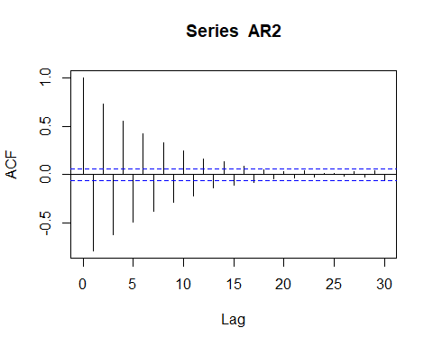

Figure 1: ACF Plot for the simulated phi values

Creating the PACF Plot

pacf(AR2)

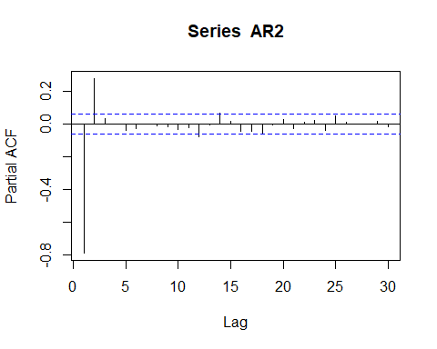

Figure 2: PACF Plot the simulation

Simulating 500 observations from an MA(3) Process

MA3 = arima.sim(model = list(ma=c(7,2,-3)),n=500)

Creating an ACF Plot for the MA(3) simulation

acf(MA3)

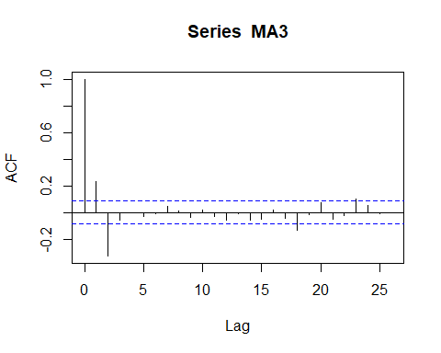

Figure 3: ACF Plot for the MA(3) simulation

Creating a PACF Plot for the MA(3) simulation

pacf(MA3)

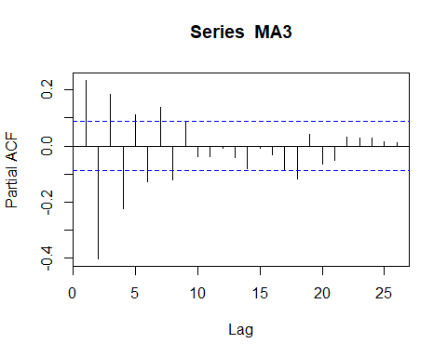

Figure 4: PACF Plot for the MA(3) simulation

**CONCLUSION**

From Figure 1, we can conclude that the ACF Plot for the phi values is oscillatory.

From figure 2, we can conclude that the PACF Plot for AR(2) cuts off after lag 2.

Since ACF plot decays slowly or gradually and PACF plot has a sharp or sudden drop after 2 lags, the process with given sets of parameters is stationary.

From Figure 3, we can conclude that the ACF Plot simulated from MA(3).

From Figure 4, we can conclude that the PACF Plot is oscillatory.

Moving average model is always stationary as it is a linear combination of white noise sequence.